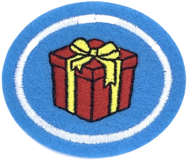
Materials suggested to accompany the Gift-Wrapping Honour being taught by Pr Mark O’Ffill at the BUC e-Club on 19th December 2020

For bows:

- 1”/25 mm Ribbon x 6’/2 metres long (plus length to go around box, this is for the BOW only)
- 4-6 rubber bands, small
- coloured duct tape
- ½’ (13 mm) Ribbon
- coloured paper contrast to wrapping paper colour
- string, twine, or cord
- stiff ribbon ¼’ (curling craft ribbon)
- 4” / 100 mm embroidery hoop
NOTE: we will use the duct tape, stiff ribbon and 25mm ribbon and likely thin ribbon/cord next week. This list matches the extensive DIY resources I have collected

For wrapping:

You will need small 5 x 7 cm squares of ten TYPES of wrapping papers. The list below reaches that goal.

You will need enough paper to wrap the following:

1) a real box or gift (“normal” printed wrapping paper) for class as well as
2) tissue papers two colours to wrap a real cylinder (soup can works for practice).
3) A third gift will need to be wrapped in recycled papers (magazines/newsprint/paper grocery bags etc). A stuffed animal or other multifaceted shape container is ideal for this one. (may be in class or by video tutorial)
4) extraordinary shape - your choice (may be in class or by video tutorial)

Colour matching bow with real life gift wrapping is recommended but not essential for qualifying for this honour.

I recommend that tissue papers and printed papers and bows/duct tape/other bow material all be in the same colour family.

Here’s the wrapping paper list—
- coloured foil
- (Kraft paper) paper bag w/ stamps / ink
- tissue paper
- foiled standard gift paper
- printed standard gift paper
- cloth (Asian traditional form)
- recycled materials (such as magazines, printed flyers, etc)
- food wrapping papers (3 types)
- scissors
- tape
- glue

