Jesus’ Special Supper
Tell the story of the Last Supper.
Review the story in e-club class
𝥷 I told the story to someone special
Explain why Jesus washed the disciples’ feet as a servant.
𝥷 I listened 𝥷 I explained to someone special
Explain what the bread and the juice represents.
Draw lines → match meaning
Jesus’ Body
Jesus’ blood
What happened at the end of the special supper? (circle all that happened)
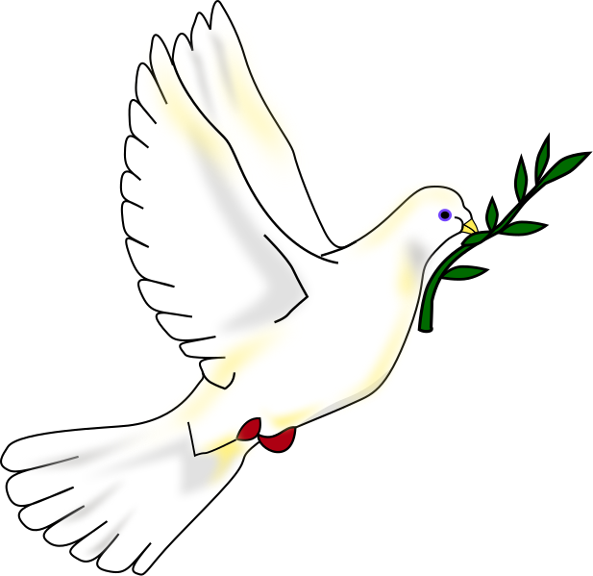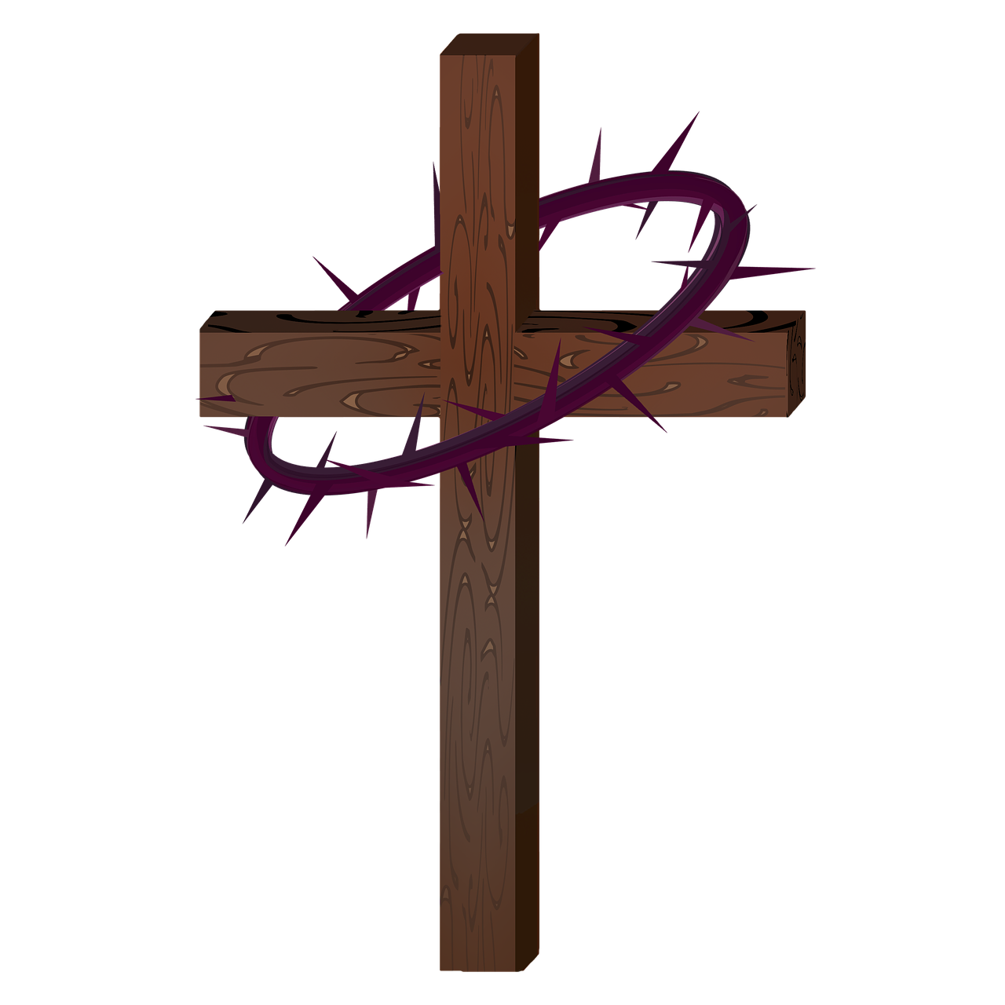
Make a craft to illustrate the Last Supper..
𝥷 I sent a photo of my craft to dejan@adventist.uk
Have a prayer thanking Jesus for HIS love.
𝥷 I prayed with Pr. Mark or my family.

