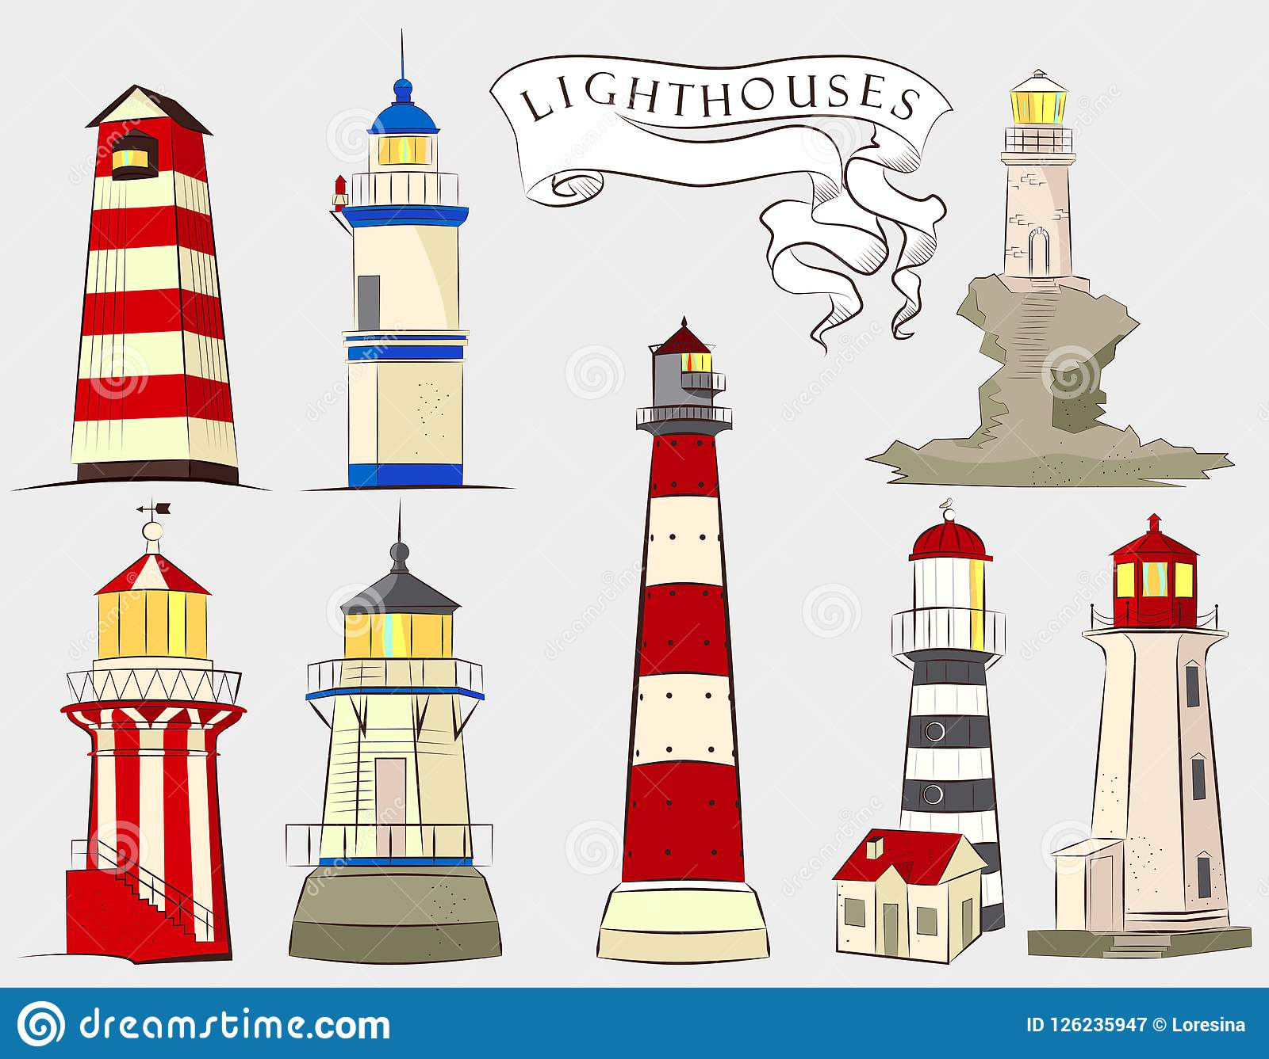

Pathfinder club
2020

Pam Catchpole
What is the function of a lighthouse?

When were the first lighthouses of record built and what was the name of the most famous?

What name is given to people who study lighthouses?

Are lighthouses manned, do they have lighthouse keepers?

What is the name of the organisation in United Kingdom that manages lighthouses?

What name is given to the lenses now used in lighthouses and what is the structure of it?

Throughout history what fuels were used for lighthouse lights?

Are all lighthouses located along the shoreline, if not , list other locations where you might find a lighthouse

What is the lighthouse service in the UK called

When a lighthouse is a visible landmark seen from the sea during the day it can be identified by certain markings. What are they called?

What is a foghorn? Why would one be used at a lighthouse? What are three things that affect how far away a foghorn can be heard?

Since lighthouses are often called “lights” explore the concept of lights in scripture by using a concordance to find ‘lights’ and discuss lights as referred to in the bible and explain why you think God’s word is like a lighthouse.

Memorise John 8:12

Write a poem or a story about a lighthouse light. Include thoughts of God’s ‘light’ Read your story or poem to your group. (Psalm 136:7-9 use as a reference)

Find, copy and paste in or draw five forms/types of lighthouse being used today.
- Octagonal

- Conical

- Cylindrical

- Square

- Skeletal

- Sparkplug

List the names and locations of five lighthouses nearest to your location.

1.

2.

3.

4.

5.

