My Church
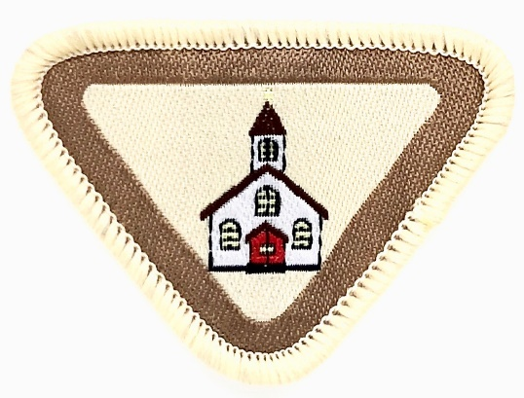
Name: ____________________ Class __________
Date ____________

- Understand the meaning and memorize I Corinthians 3:16 and learn the song “Lord, Prepare Me to Be a Sanctuary.”
______________________________________________________________________________________________________________________________________________________________________________________________________________________________________________________________________________________________________________________________________________________________
- Know the name of your church, and write the address. As a club, draw a mural with the church in the center and include each Adventurer’s house in relation to our church, naming all roads and streets as a map to the church.
CHURCH NAME:_________________________________________________________________
ADDRESS:____________________________________________________________________________________________________________________________________________________
ADD YOUR DRAWING
- Who is your pastor and what is his/her responsibility?
Ask the following questions.
a. Why did you decide to become a Pastor?
b. At what age did you decide to become a Pastor?
c. Was there something that happened in your life that caused you to want to be a pastor?
d. Can I be a pastor, if God calls me?
e. How can I prepare for a life to serve God?

f. How can I be a minister right now?

- Draw the floor plan of your church. If your church has the following, label them on your map.
a. Sanctuary
b. Church Office
c. Your Sabbath School Room
d. Fellowship Hall
e. Restrooms
f. Adventurer Room
g. Community Service Room

- What is a church board and what is its function? __________________________________________________________________________________________________________________________________________________________________________________________________________________

- Name 10 members on the church board. What position(s) do they hold?
  - _
  - _
  - _
  - _
  - _
  - _
  - _
  - _
  - _
  - _

- Explain how you can help God in your church every week starting this week?

Purpose of My Church Award:
To understand the many roles of church members in the function of the church.
Resources:
The SDA Church Manual
The Nominating Committee’s Report
The Pastor

