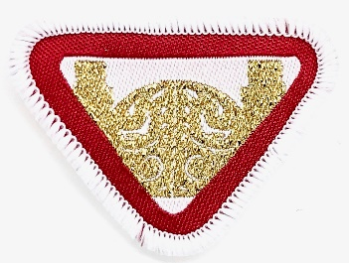
Pearly Gate
British Union e-Award
This award is intended to make children aware of and look forward to the Second Coming and Heaven.
Requirements:
- Where can we find a promise in the Bible that tells us Jesus will come again?

2. Name a Bible book and chapter that describes Last Day events.

3. Make a list of the signs of Jesus' Second Coming, found in Matt. 24:3-14.

4. Describe Jesus' ascension of Heaven and tell how it is like or unlike the way He will return.

- Describe what the Holy City OR New Earth will be like according to the following texts:
Isaiah 65: 17-25 describes the New Earth as a place where:

OR Revelation 21: 10 – 27 and Revelation 22: 1-6 describes the Holy City as:

6. Complete and memorize John 14:2,3. Fill in the blanks:

"In my Father's __________________ are many ________________________;
if it were not so I would have ___________________ ______________.
I go to ___________________ _____ __________________ for you.
And if I go and ____________________, I will ___________ _______________,
and receive you unto ________________________;
that where ___________________, there _________________ may be also."

b) Act out a parable from the Bible about Jesus’ second coming.
7. Close your eyes and imagine meeting Jesus at the Pearly Gate, then either draw a picture of what you imagined (on another piece of paper) or create what the Pearly Gate would look like.

Award completed on: ___________________________
Signed: _______________________________________

