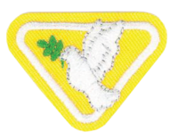
Holy Spirit Award materials list

- Bibles
- Holy Spirit Award Worksheet
- Pencil
- White Paper Plate
- Scissors
- Orange and blue markers or crayons
- Glue or stapler

